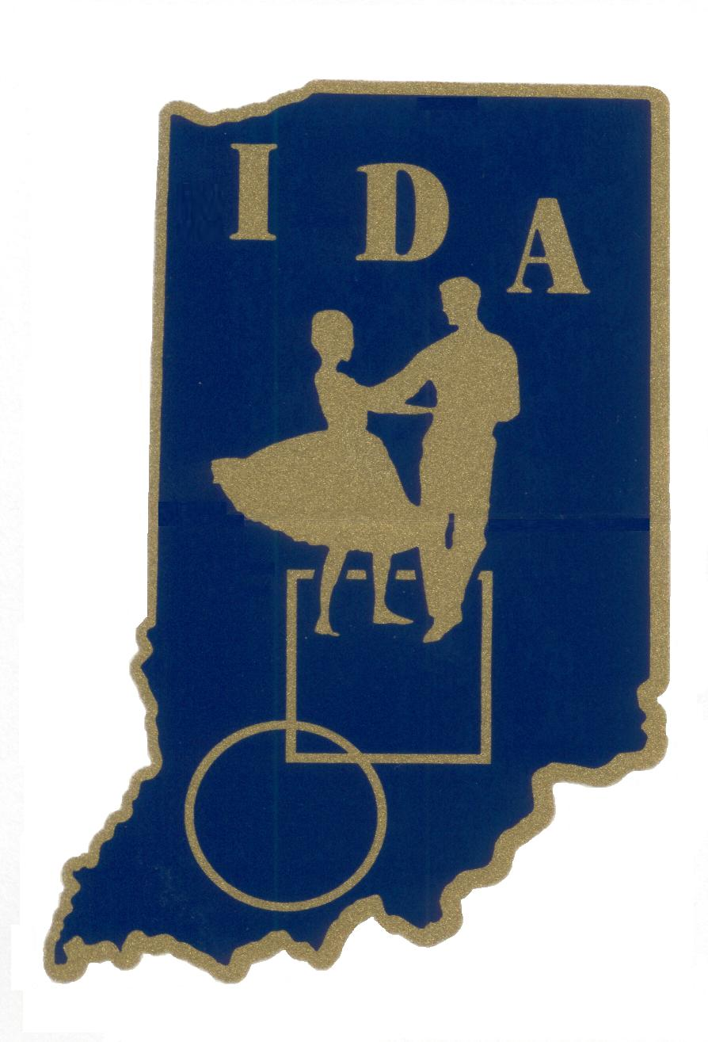
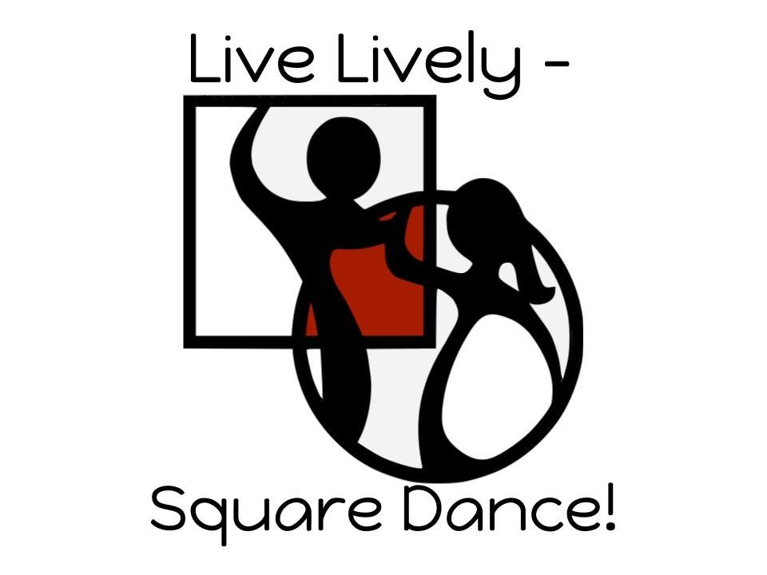

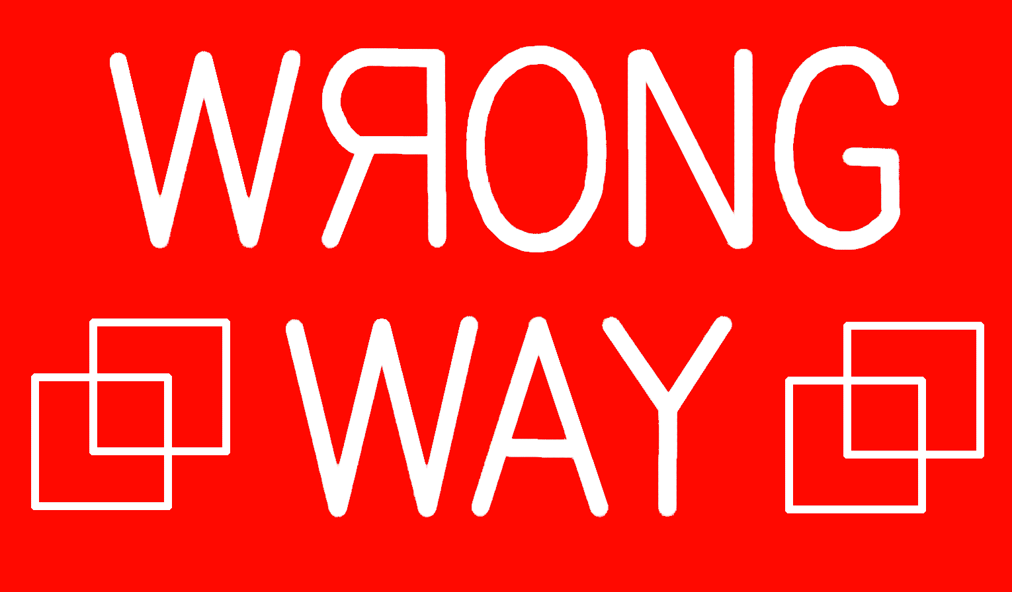
Hebron Elementary School Cafeteria
307 S Main St Hebron, Indiana 46341
2  0  2 1 |  | Theme | Caller | Cuer
2  0  2 1 | Sept. 11 | California Dreaming ~ Casual | Chuck Witt | Shirley Heiny ~ R
2  0  2 1 | Oct. 09 | Glow in the Light Tonight ~ Blacklight | Tom Manning | Pat Bryant ~ R
2  0  2 1 | Nov. 13 | 49th Anniversary Dance | Chuck Witt | Shirley Heiny ~ R
2  0  2 1 | Dec. 11 | Silver Bells Dance | Bobby Poyner | Larry Johnson ~ R
 | Jan. 08 | These Boots are made for Dancing ~ Welcome new Dancers | Chuck Witt | Linda Scott ~ L
2  0  2  2 | Feb. 12 | A Sweet Time in Candyland | Barry Johnson | Aurora de Jong ~ L
2  0  2  2 | Mar. 12 | Irish Eyes are Smiling | Chuck Witt | Linda Scott ~ L
2  0  2  2 | Apr. 09 | A Hopping Good Time! | Ralph Hardy | Aurora de Jong ~ L
2  0  2  2 | May 14 | Mountain (Magic) Wild Flowers | (4) Mountain Magic Callers | Squares ALL Night
2  0  2  2 | Jun. 11 | All Star Graduates ~ Casual | Don & Doug Sprosty | Doug Sprosty ~ R
2  0  2  2 |  | Summer Break
2  0  2  2 | Sept. 10 | Fall into Dancing ~ Casual | Chuck Witt | Shirley Heiny ~ R
2  0  2  2 | Oct. 08 | Dancing in the Blacklight | Kristy Williams | Pat Bryant ~ R
2  0  2  2 | Nov. 12 | 50th SPECIAL Anniversary Dance | Tom Miller & Chuck Witt | MS/Plus/DBD/Advance  Squares
2  0  2  2 | Dec. 10 | Do-Si-Do HO! HO! HO! | 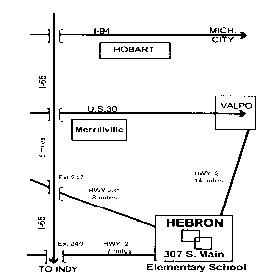  Chuck Witt | Larry Johnson ~ R

A FUN Place to Dance
2nd Saturday (Sept. – June)
7:00 – 9:30 pm (Chicago Time)
Mainstream w/ DBD & Plus Tips
Contact: Larry or Rose Hakes Lmhakes@aol.com
Cell (219) 575-9311
www.WrongWaySquares.com

